No no – not from ME silly. My sister, Mary is currently cooking a bun in the oven with her husband of 3+ years Nige. The due date is sometime around Valentines Day of 2003. This means I’ll be an uncle! (Well, and Mary and Nige will be parents – just a minor even there as well – hey, it’s my newsletter not theirs).
Mom will be going over to participate in the joyous occasion shortly after the baby is born (she hopes – the airline ticket has been bought already and if the baby isn’t there yet…well…). Because of her due date being so close to Christmas we celebrated Christmas 2002 over Thanksgiving when Mary and Nige come over for 10 days. Joel, Christine and myself all chipped in and bought them a really nice digital camera. It’s the gift that just keeps on giving – at least we all hope. So if you want to see pictures of the little one once he or she is born, make sure I have your email address so I can forward them to you as they become available.

Dear, Michael & Jennifer,
2002 has actually been a pretty darn good year for me. The most significant (and important) change in my life has been the addition of a certain female redhead. I took off the last week in June this year and picked up a 10-week old Golden Retriever – her name is Abby. Granted she’s only 8 months old as of this writing, but she’s already potty trained (with the occasional accident when I’m not paying attention), knows how to sit, lay down, and we are working on the “stay” command. As recently as a month ago she has learned that “fetch” is a great game. So we’ve been going to all sorts of open areas where I can throw balls and fetching toys for her to chase after.
Abby and I try to go for nice long walks in the neighborhood for exercise as often as we can. We recently found an off-leash dog-park near my house where she gets to romp around with all the dogs that are there. Needless to say, we’ve become one of the “regulars” there. Of course there isn’t any comparison to the Doggie Daycare she goes to twice a week. Just imagine, a good-sized area where 10 to 15 dogs get together and, well, do dog things. I know I know – that sounds SO wrong. But believe me – I take in at the start of the day one very wound up highly energetic pup and take home one very exhausted pooch at the end of the day.
Joel and Christine have taken her for a few rounds of walking, and a trip to Christine’s folks house once in a while. I cannot express how grateful I have been to them for helping me with Abby as she’s gone through her puppy stages.
With that in mind, I’d also like to express a sincere thank-you to several of my neighbors (you know who you are) who have assisted me with the first several months of having Abby. While I took the first week I had her off, the following weeks she still was a little too young to leave home alone for an entire workday. They came over and took her out to go to the bathroom and let her play a little bit.
Puppy training came early for Abby – and I think it’s paying off in the long run. She’s growing up to be a very well behaved dog – and is happy to meet anyone at anytime. So if you’re ever up in the neighborhood and want to meet the new addition, she’ll be happy to show you around.

2002 – Going to the Dogs

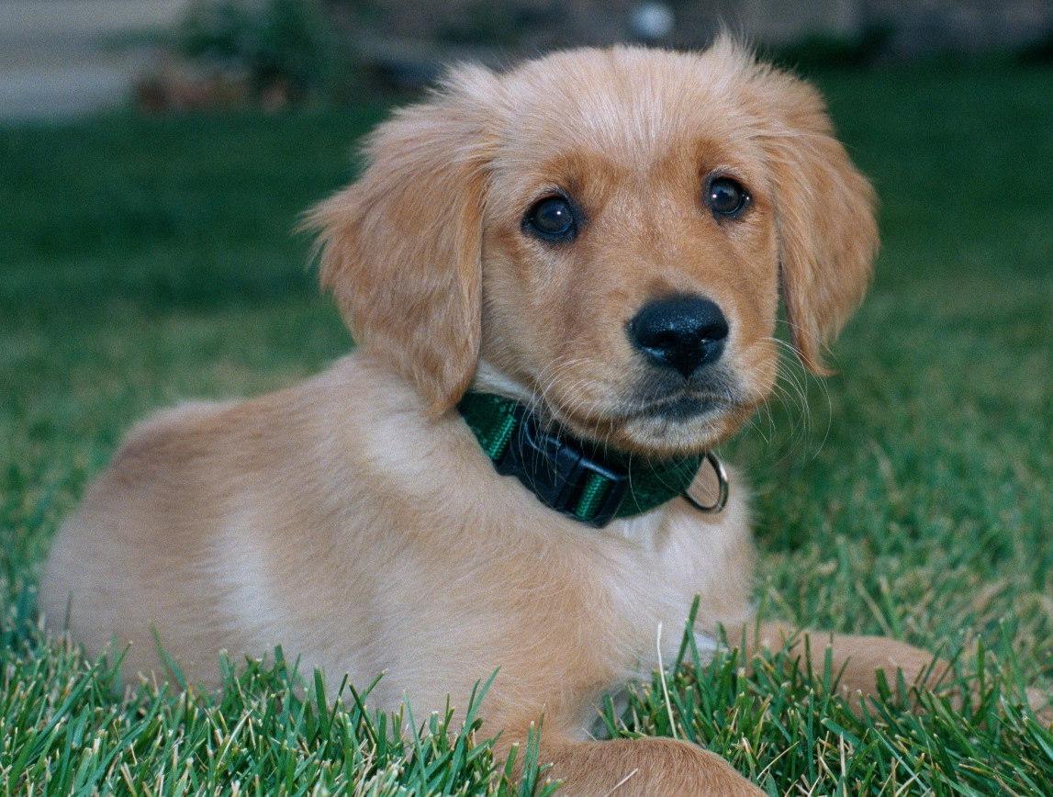

Baby News? from Brian…?
Happy Holidays!

Joel’s Grilled Pizzaria

What a great name for a diner, eh? At least many of the people who were able to attend this year’s annual grilled pizza event thought it should be turned into one. For those of you who missed it, the past couple of years Joel, Christine and myself have been having a grilled pizza party.
What is a Grilled Pizza party you say? Well, it’s quite simple (or at least Joel makes it appear that way), take one part of pizza dough (freshly prepared of course!), grill one side until it’s done, kind of like a pancake. Once that side is done, flip, ad sauces and toppings as desired. Then cook with the lid down until the cheese (or whatever other topping you’ve selected) is melted. At that point, take off the grill and devour. I still get these weird looks when I invite someone new to the party. One such person cautiously asked, “You really are going to actually ‘grill’ a pizza?”
Next year’s event will be around the end of summer again (Uhm, Joel – mark that down in your calendar will ya?) since that seems to be a good time for most people.
At the end of the party this year Christine was playing around with desert type of toppings for pizza – and for those who left a little early – you missed out. Hopefully we’ll be able to con her into re-creating this masterpiece yet again.!
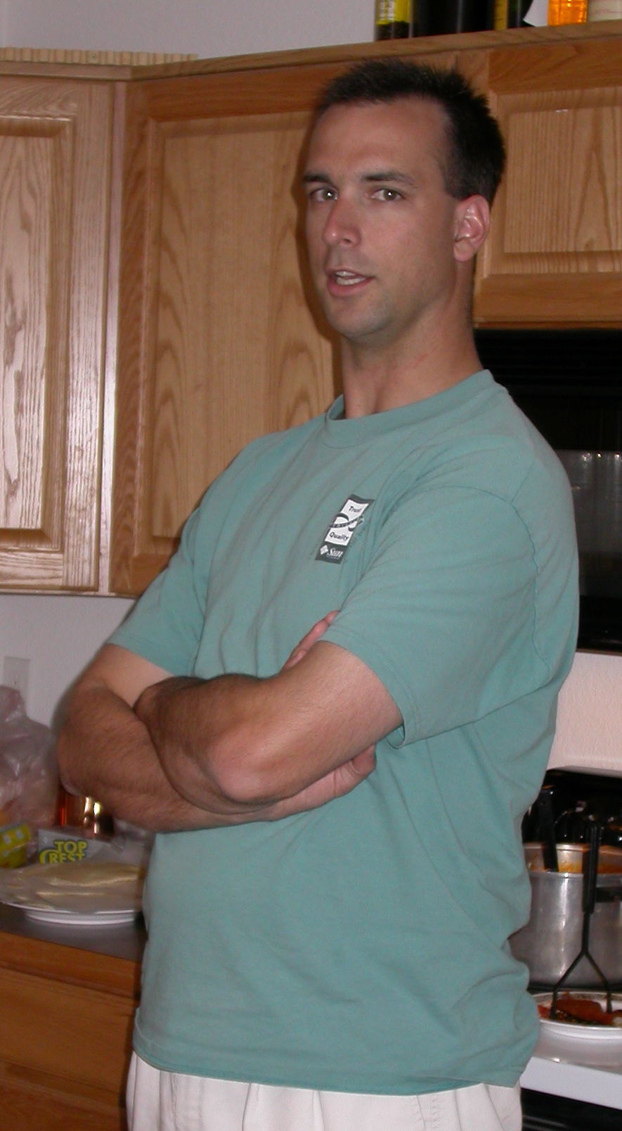

Spiritually speaking….

Church was never one of my “things”. I resisted the thought of going in my mid-teens and when I was finally to a point of being able to make my own choices I completely quit going all together.
The past few years in my life I’ve really re-examined that part of my core values and found that I was missing something. I have been very fortunate to have a good friend of the past 10 years that has been very patient with my struggles and beliefs in life. Starting this past April I started attending church at the New Community Christian Church. It’s a great organization. It’s extremely contemporary and a casual environment, but yet the messages delivered speaks to the heart and soul of my struggles. I still am learning about where my place is in a Christian experience, but with each day I grown a little more comfortable in it.
I also would like to take this moment to extend a very heart-felt thanks to so many friends in my life who have helped me grow spiritually, in healing and in encouraging me so much this past year. It has not gone unnoticed, and I genuinely cherish your friendship and support.
With that kind of support, 2003 is going to be a kick-butt kind of year. I look forward to sharing it with all of you!

